# Android practicum part 1.2: Getting to work

## Android Hello World

Ok, all the tools are in place so let’s get started with a Hello World.

Luckily Google has create a nice Hello World tutorial.

Start here

* <http://developer.android.com/training/basics/firstapp/index.html>

Continue with this (Create a Project with Command Line Tools is optional)

* <http://developer.android.com/training/basics/firstapp/creating-project.html>

When finished continue with this (If you don’t have a device, just use the emulator:

* <http://developer.android.com/training/basics/firstapp/running-app.html>

Finally go here:

* <http://developer.android.com/training/basics/firstapp/starting-activity.html>

When you are done, make sure that the project is added to your repository.

## Playing with Layout

Ok, the hello world is done. But the UI is a bit empty.

* Create a new Android project. A good name would be: Android_components
* Open the activity_main.xml layout using the Graphical Layout view.

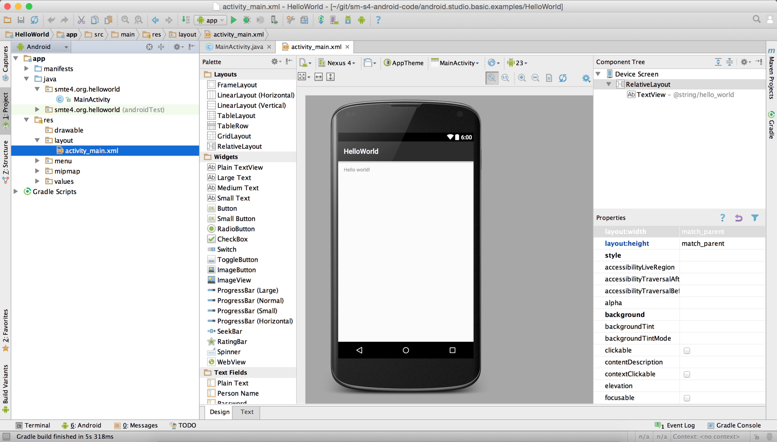Fig 1: Example of adding an activity using Android Studio.

* Add a number of different components on the view (At least 4)

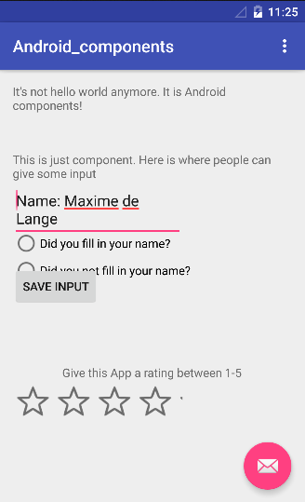Make a screenshot from the end result, and paste it here.

Now go to developer.android.com and find the official documentation for the UI components you’ve found, and paste the URL’s below.

Links:

Buttons:

<http://developer.android.com/reference/android/widget/Button.html>

Radiobutton

<http://developer.android.com/guide/topics/ui/controls/radiobutton.html>

Ratingbar

<http://developer.android.com/reference/android/widget/RatingBar.html>

Input text field

<http://developer.android.com/guide/topics/ui/controls.html>

Single line text field

<http://developer.android.com/guide/topics/ui/controls/text.html>

## To conclude

## Make sure that this document is uploaded within your repository.